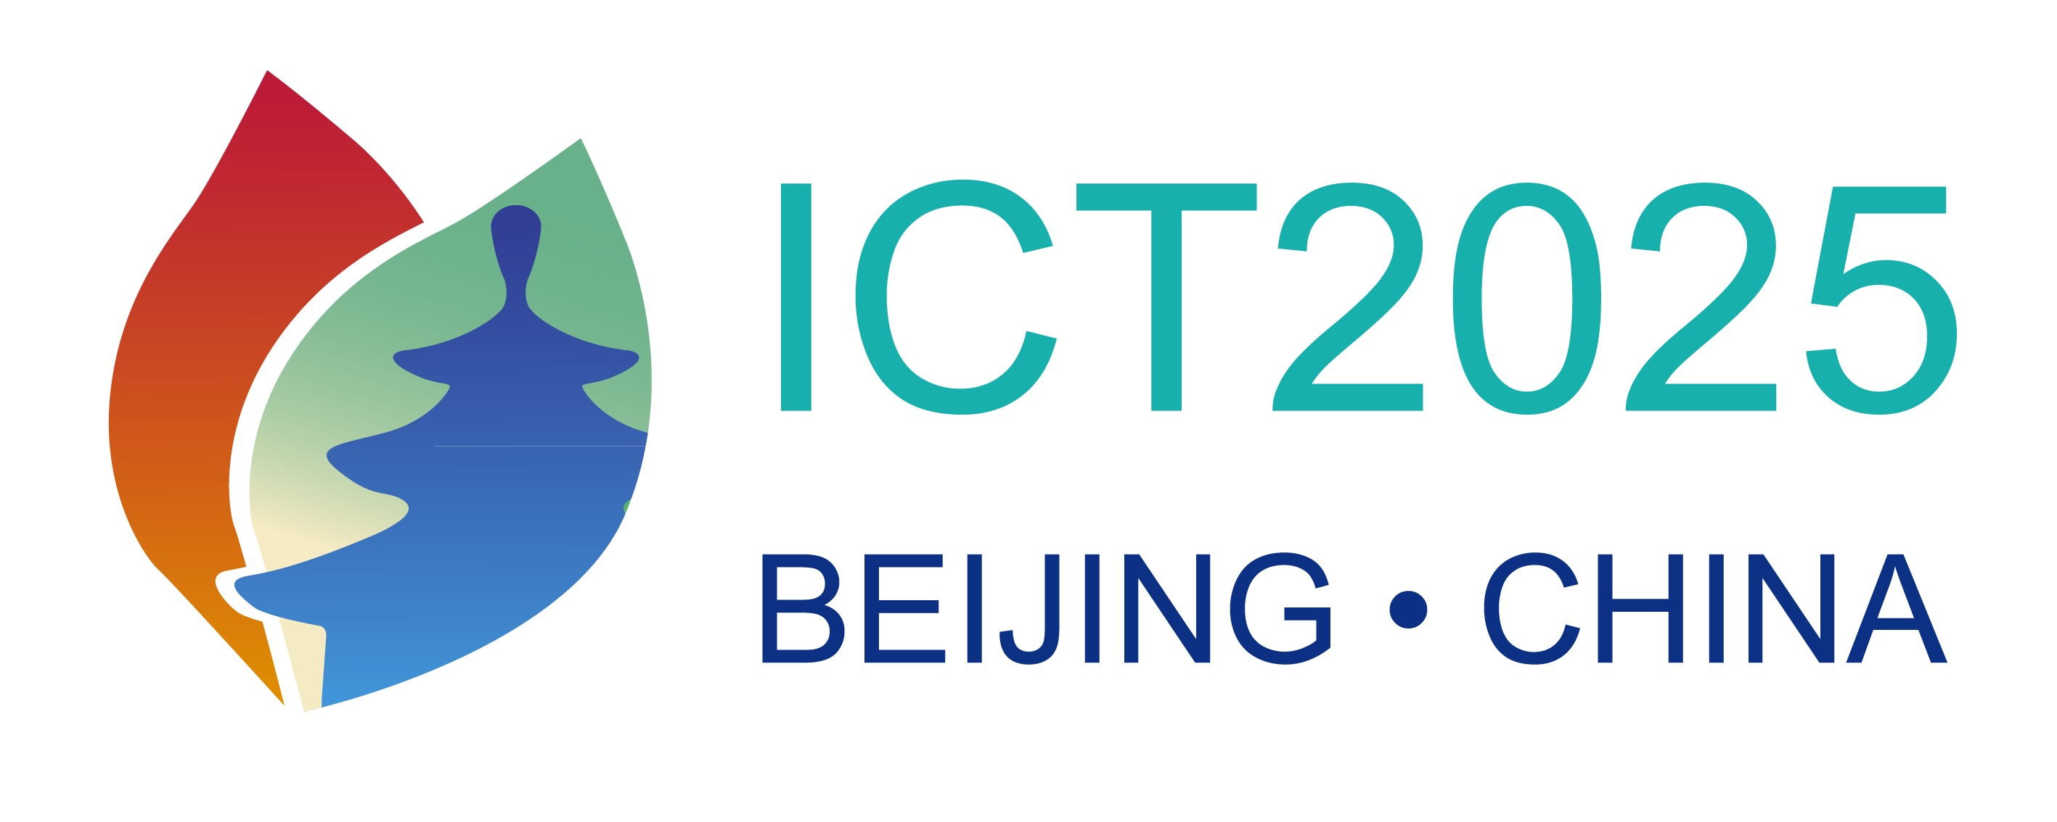
Submit via email to org-ict2025@chntox.org by May 31, 2024

Please read the last page of this form for general guidelines

Proposal for (mark with “X”):
 | Keynote Lecture# (1 Speaker, 45 min) |  | Continuing Education Course (CEC)#  (4-6 speakers, 10am – 4pm)
 | Symposium# (3-4 speakers, 90-120 min. on a topic of wide interest) |  | Other (please indicate)
 | Workshop# (3-4 speakers, 60-90 min. on a specific topic)
#: Before completing, please read the guidelines on page 3

Promoter (Society, Institution, Individual)
Promoter Contact Email

Tentative Title:
Chairperson (Institution, Country, Email)

LECTURES/SPEAKERS
 | Tentative Title | Proposed Speaker (Name, Institution, Country, Email)
1
2
3
4

Provide up to 5 key words for your proposal:

Please indicate or describe possible sponsorship or funding

Short description (abstract) of the proposal (max. 200 words)

Please declare any perceived and/or real conflict of interest

General Guidelines
- Geographical distribution (aim for not more than 2 speakers from the same country, except for CECs)
- The Congress Organization encourages interaction between Academia-Industry-Regulators and interdisciplinary approaches (basic research, clinical/epidemiological, regulation). Where possible, please include speakers from different stakeholder groups and scientific disciplines.
- The Congress organization is committed to the principles of diversity, equity and inclusiveness and strongly encourages the inclusion of developing countries participants in the activity.
- The proposal may be either a full proposal (including all speakers) or an open proposal which allows the integration or addition of other lectures/speakers.
- The official languages of the Congress will be both english and spanish. Simultaneous translation will be provided.
- Send proposal to org-ict2025@chntox.org by May 31st

Specific Guidelines on preparation of session proposals for ICT2025

- Symposia: A more formal session where 3-4 expert speakers present in depth analyses on a topic of wide interest. 90 - 120 minutes is allocated; speakers should each have 25 min. presentation time and 5 minutes for questions (discussion).

- Workshops: A more interaction session where 3-4 speakers address a specific topic or an issue where views may differ, or conclusions have yet to be reached. 60 - 90 minutes is allocated; speakers should have 15-20 min. presentation time with 5-10 min. allocated for discussion after each talk and time for a summary discussion at the end.

- Continuing Education Course: An educational session with 4-6 experts in the field. Scheduled for 3 – 4 hours either in the morning or afternoon.

- Keynote lectures: 1 speaker, 45 minutes. International renowned leaders in the field to present recent hot topics or issues of broad interest.

- Other – if you wish to propose alternative formats for sessions e.g., roundtable discussions, pro-con debates etc. please use this option.

